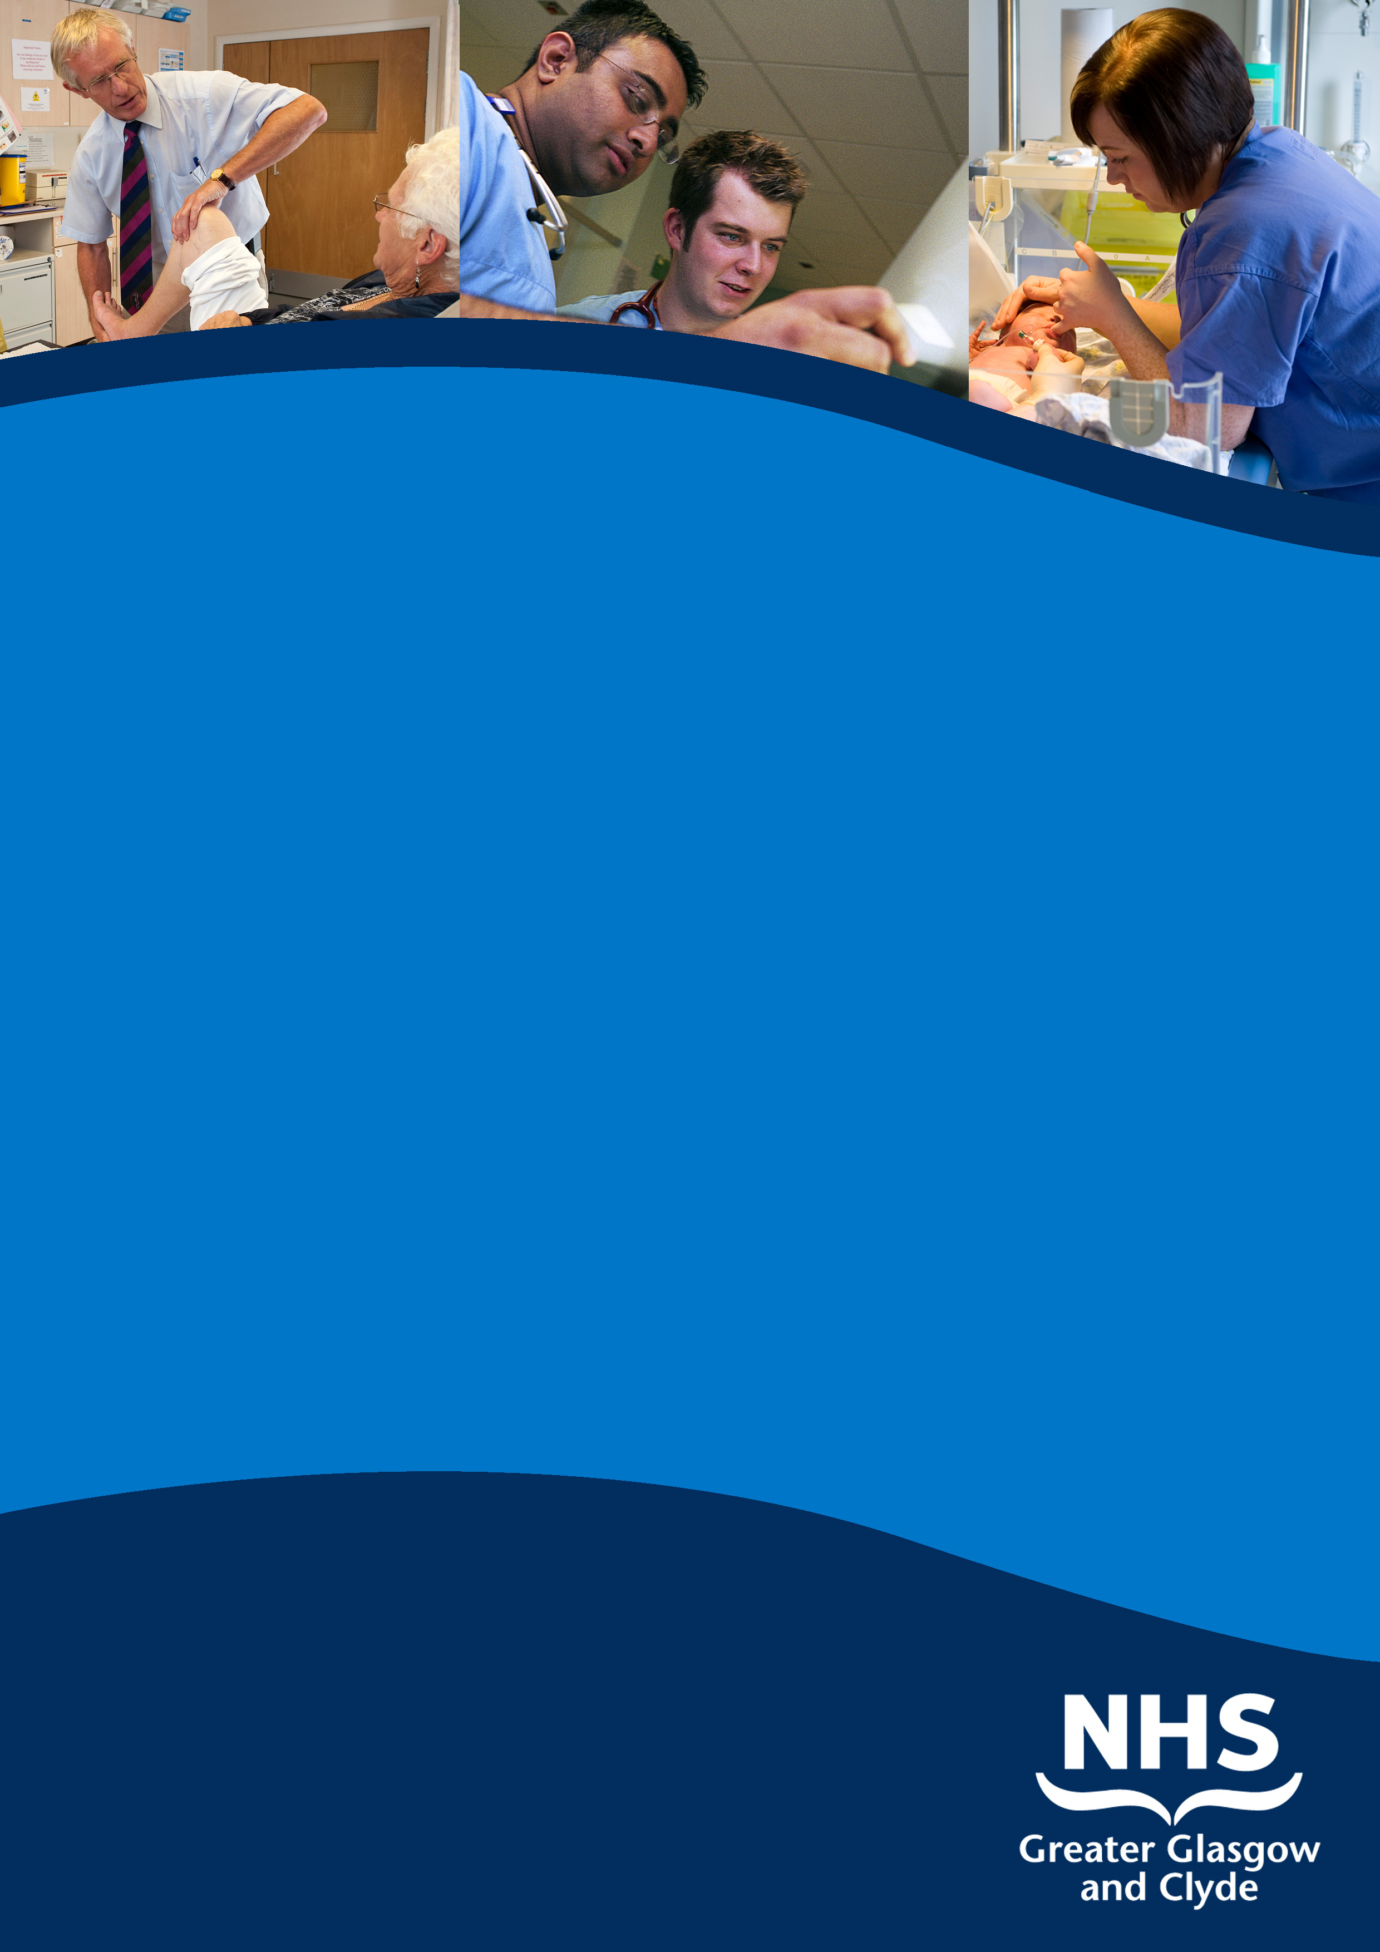

consultant
DIAGNOSTIC neuroradiologist

Institute of Neurological Sciences
queen elizabeth University Hospital, glasgow

candidate INFORMATION PACK

REF: 40522D/ G982

cLOSING DATE: noon monday
15th february 2016

SUMMARY INFORMATION RELATING TO THIS POSITION

Post: consultant DIAGNOSTIC neuroradiologist

Base: Institute of Neurological Sciences
QUEEN ELIZABETH UNIVERSITY Hospital CAMPUS

Location: Glasgow

SALARY: £76,761- £103,490

relocation package where appropriate

This is your opportunity to apply for one of our exciting Consultant Diagnostic Neuroradiology positions in our advanced, state of art imaging department in NHS Greater Glasgow and Clyde

As one of the largest health organisations in the UK, NHS Greater Glasgow and Clyde continues to be at the forefront of innovation and change with the delivery of a £1billion modernisaton programme with the opening of the Queen Elizabeth University Hospital and the new Royal Hospital for Children, Glasgow, both in the Queen Elizabeth University Hospital Campus.

The Directorate of Diagnostics is responsible for the provision of Imaging (including Neuroradiology), Laboratory Medicine, Clinical Physics and Bio –engineering and Medical Illustration across the whole of NHS Greater Glasgow and Clyde and forms the largest Diagnostic entity in Europe.

Integral to our modernisation programme is also the development of a £50 million clinical research infrastructure which has resulted in one of the worlds most advanced centres for stratified medicine providing a focus for innovation in a clinical setting. Our close links with the University of Glasgow Teaching and Learning Centre on the QEUH site enables opportunities to pursue academic and clinical teaching interests.

NHS Greater Glasgow and Clyde has invested £15 million in new facilities and equipment, specifically in the areas of CT, MRI, Ultrasound, Digital Mammography, PET CT / SPECT, Angiography and General Digital Imaging. The South Imaging sector includes the new adult Queen Elizabeth University Hospital, Victoria ACH and Gartnavel General Hospital. This post will be based in the South Sector Hospitals in the Institute of Neurological Sciences.

Applications are invited from enthusiastic, talented specialists to become members of our existing Diagnostic Neuroradiology Team, providing experience and support for a range of diagnostic procedures which cover adults and paediatrics. With the respect of your peers and exuding gravitas and credibility, you will be a newly qualified or established Consultant Diagnostic Neuroradiologist who is able to demonstrate the key qualities and behaviours that will influence the continuing success of the existing team.

Applicants must have full registration with the General Medical Council, a licence to practice and be eligible for inclusion in the GMC Specialist Register. Those trained in the UK should have evidence of higher specialist training leading to CCT in Clinical Radiology or eligibility for specialist registration (CESR) or be within 6 months of confirmed entry from date of Interview. Non UK applicants must demonstrate equivalent training.

For further Information, in the first instance please contact Lorraine Porteous at our Recruitment Partners, Aspen People, on 0141 212 7555 or email mscholes@aspenpeople.co.uk

Informal enquiries to the department will be encouraged and arranged to suit candidate’s availability.
Closing date: Noon Monday Monday 15th February 2016
Interviews are scheduled to take place in Glasgow late March 2016.
Job Reference Number: 40522D/G982

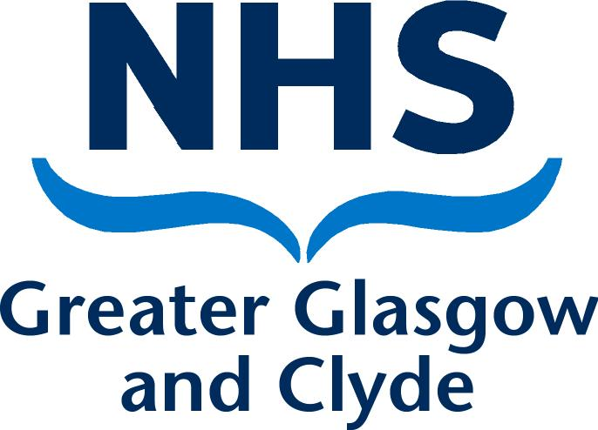

NHS GREATER GLASGOW AND CLYDE

DIAGNOSTICS DIRECTORATE

CANDIDATE INFORMATION PACK

FOR THE POST OF

CONSULTANT DIAGNOSTIC NEURORADIOLOGIST

1. Glasgow – A Fantastic Place to Live and Work

Glasgow has a wealth of attractions including some of the UK's finest Victorian architecture, internationally acclaimed museums, galleries and cultural venues all thriving in a unique cosmopolitan atmosphere. The renaissance of Glasgow over the last two decades is an urban success story to which many major UK and European cities aspire.

Glasgow is now one of Europe's top cultural capitals with a complete all year calendar of festivals and events. Native Glaswegians and visitors enjoy widely acclaimed bars and first class restaurants nestling within the best commercial shopping district outside London. All of this is located within a stone's throw of some of the country's finest parks and gardens.

Glasgow is the gateway to Scotland's most spectacular scenery, with Loch Lomond and the Trossachs only 40 minutes away. Glasgow is at the core of national rail and road networks and is served by two airports, Glasgow International (close to the South Glasgow University Hospital) and Glasgow Prestwick International (on the Ayrshire coast, south-west of the city).

2. The Hospital Modernisation Programme - The Services of Tomorrow

The Diagnostics Directorate took over responsibility for all Diagnostic services in February 2006.

A major re-organisation of NHS Greater Glasgow and Clyde’s Acute Services has just been completed. The re-organisation was essential to align the organisational structure to the Acute Services Review (ASR) recommendations and support the Hospital Modernisation Programme which is transforming healthcare provision locally, regionally and nationally. More than seven hundred million pounds of investment underpins an ambitious building programme that will deliver truly world class and integrated care from the following major acute sector units:

- New Cancer Centre, PET CT Imaging Centre, opened in 2007 on the General hospital campus at Gartnavel.
- Development of a single dedicated Regional Cardiothoracic Centre at Golden Jubilee hospital completed 2008.
- Ambulatory Care, Diagnostic and Treatment Centres at the Stobhill and Victoria sites, completed June 2009.
- New Acute South Glasgow Hospital –The Queen Elizabeth University Hospital with co-location of Maternity and the new Children’s hospital – The Royal Hospital for Children. Regional Neurosciences and Maxillofacial Centres are also on site. Completed spring 2015.
- Re-development of Glasgow Royal Infirmary into the second major acute hospital from 2015.

The purpose designed facilities will enable the one-stop/rapid diagnosis and treatment models required for the future. State of the art IT services and PACS currently allow patients’ images and diagnostic results to be available throughout the city and beyond, regardless of which hospital site is providing services.

3. Greater Glasgow & Clyde Acute Services Division

Glasgow Acute Services Clyde Acute Services
15 Hospitals 3 Hospitals
4,700 beds 1,100 beds
£980m income £250m income
19,500 wte staff 7,000 wte staff

The Acute Division brings together all acute services across Glasgow and Clyde under a single management structure led by the Chief Operating Officer. The Division is made up of a Sector based model covering South, North East and Clyde. Facilities and Diagnostics continue to work to a pan Greater Glasgow and Clyde.

4. Diagnostics Directorate

NHS Greater Glasgow and Clyde serves a population of around 2 million located across the West of Scotland. The New Cancer Centre serves a population of around 2.8 million i.e. over half the population of Scotland.

The Diagnostics Directorate has responsibility for all:

- Laboratory services
- Clinical Physics
- Medical Photography
- Bio engineering
- Diagnostic Imaging

Diagnostic Imaging includes:

- Clinical Radiology
- Nuclear Medicine
- Regional Imaging services (Neuroradiology, Paediatric Radiology, Oncological Imaging/PET CT, Breast Screening and Dental Radiology)

5. Diagnostic Imaging

Adult acute Radiology services are organised on a sector basis with Clinical Leads covering each sector (North West, North East, South and Clyde).

Clinical Leads for Neuroradiology, PET CT, Paediatric Radiology and Breast Screening services are also in post. Clinical Leads report to the Clinical Director (Dr. Ross MacDuff) and General Manager (Mrs Lynn Ross).

North Sector Lead
(Glasgow Royal Infirmary and Stobhill) Vacant

South Sector Lead
(GGH/WIG and QEUH /VIC) Dr Andrew Downie

Clyde Sector
(Royal Alexandra and Inverclyde Royal Hospital
and Vale of Leven Hospital) Dr. Marzi Davies

Acting Neuroradiology Lead
(Institute of Neurological Sciences) Dr. Douglas McCarter

Paediatric Radiology Lead
(Royal Hospital for Children) Dr. Ruth Allen

Breast Screening Lead
(Breast Screening Unit) Dr. Hilary Dobson

PET CT Lead
(Greater Glasgow & Clyde) Dr S Han

Interventional Lead
(Greater Glasgow & Clyde) Dr. Ram Kasthuri

The key strategic aim of the Directorate is to improve the quality of care provided to patients on the basis of clinical need by consolidating acute/emergency imaging support on a 24/7, 365 day basis and by complying with emergency, cancer related and scheduled care National waiting times targets.

The NHS Greater Glasgow and Clyde out of hours imaging model for the adult acute service includes robust vascular/interventional on-call cover city wide and parallel non interventional cover on a site and sectoral basis. The interventional neuroradiologists provide a seven day neurointerventional service for aneurysmal subarachnoid haemorrhage, with a Scotland wide remit in conjunction with colleagues in Edinburgh. This seven day service has been operational since April 2007.

Out of hours/weekend imaging cover is currently supported by the vast majority of NHS Greater Glasgow and Clyde Consultant Radiologists, mainly on a site by site basis.

There is currently a pilot in place on the South sector providing extended evenings and weekend cover within a framework of recognised contractual hours this has been widely received and is currently being evaluated.

6. The Imaging Departments

General Information

An HSS RIS system covers all the NHS Greater Glasgow and Clyde departments.

NHS Greater Glasgow and Clyde is the lead site for the Scottish National PACS implementation and completed National acceptance testing in January 2007, triggering the roll out which was completed in mid 2008.

Voice recognition technology has been introduced at all NHSGG&C sites along with upgrades to the RIS/PACS systems. The Trak-care PAS is currently being introduced across GG&C and by autumn 2013 electronic requesting with ‘Order Comms’ will be in operation across all sites.

All acute adult and paediatric hospitals and the ambulatory care hospitals have provision of modern mulltislice CT and 1.5T MRI systems. In addition, a 3T magnet is available at the regional neurosciences unit on the South Sector housed in the Institute of Neurological Sciences.

A Regional PET CT Centre with 2 modern PET CT scanners and on site cyclotron support has been developed adjacent to the New Cancer Centre.

Dedicated Vascular/Interventional facilities are available at Gartnavel General Hospital, QEUH, and Glasgow Royal Infirmary and in Neuroradiology of the Institute of Neurological Science. Paediatric vascular/Interventional facilities in The Royal Hospital for Children are shared with Cardiology.

Total imaging examination numbers for Glasgow & Clyde approach over 1 million per annum (excluding Obstetric US and Cardiology) the annual incidence of cancer for the Glasgow area is in the order of 7,000 cases. Regional services cover up to half the population of Scotland, potentially doubling the caseload for some patient pathways.

The Diagnostics Directorate currently employs around 116 individual Consultant Radiologists across Glasgow including Clyde;

- South 24
- North West Sector 22
- North East Sector 23
- Clyde 21
- Neuroradiology 10
- Paediatric Radiology 7
- Breast Screening 7
- Dental Hospital 2

Around 50 Specialist Registrars rotate through the West of Scotland Training Scheme.

The Institute of Neurological Sciences

The Institute of Neurological Sciences (INS) is located on the South Sector, Queen Elizabeth University Hospital Campus in the southwest of Glasgow.

The INS is a tertiary and quaternary referral centre providing both regional and national clinical services. Regional services comprise clinical neurosciences (neurology, neurosurgery, neurophysiology, neuropathology and neuroanaesthesia) to the 2.7 million people in Glasgow and the West of Scotland.

There are currently 9 consultant neurosurgeons (90 beds) and 25 consultant neurologists (36 beds). Associated specialties such as neuro-oncology, neuro-otology, neuro-ophthalmology also attend. Oral and maxillofacial surgery (12 consultants) is also based here, providing trauma and elective surgery and specialist provision for head and neck cancer and cervicofacial vascular malformations. Acute stroke services for the south of Glasgow have been amalgamated at the INS. This service will increase with transfer of stroke services from GGH to the QEUH.

National services comprise the Queen Elizabeth National Spinal Injuries Unit for Scotland at which provides acute and rehabilitation care for the whole of Scotland, replacing former facilities in Edinburgh and Glasgow. Glasgow shares the national coiling service for cerebral aneurysms (with Edinburgh) and forms the Northern axis of the two-centre UK vein of Galen National Service (in partnership with Great Ormond Street Hospital in London) taking referrals from the 25-30 million population of the Northern half of the UK and beyond.

The department has the following equipment:

- A 3.0T GE MRI unit with NHS and research sessions was installed in 2005.
- A 1.5T GE Signa Horizon MRI Scanner was installed in 2001.
- Two multislice CT Scanners: 64-slice Philips CT Scanner (installed 2006) with iDOSE (installed 2011) and a Marconi/Philips MX-8000 4-slice scanner (installed 2001).
- A Phillips 20-10 Allura biplane, flat panel neuroangiography unit with rotational facilities was installed in 2007.
- Backup angiography is provided by an OEC mobile C-arm with digital angiography facility and a mobile tilting table.
- Digital dental and OPT units were installed in 2002 and CR in 2003.

A transcranial Doppler service is also provided three days per week; the scanning is performed by radiographers and supervised by a Consultant.

A new (NeuroSPECT unit has just been installed measuring cerebral blood flow with Ceretec is its major function although more recently tracers such as FP-CIT have been developed to study neuronal transporters. Other ligands such as Thallium and Tyrosine scans are used routinely in brain tumour analysis.

As part of the research programme a 3T MRI scanner and a 360 slice CT scanner is housed in the imaging department at INS.

The department is linked to the national wide PACS system and has obtained its own server providing on-site storage of its studies, local display protocols and own digital teaching file.

Clinical conferences are held weekly with neurosurgeons, neurologists, oncologists, spinal injuries unit, stroke /TIA team and the head and neck cancer group.

The following Consultant Neuroradiologists are based in INS.

Consultant Specialty Interest

Dr Jo Bhattacharya Interventional/Diagnostic/Neuroradiology
Dr Sarah Jenkins Interventional/Diagnostic/Neuroradiology
Dr Aslam Siddiqui Interventional/Diagnostic/Neuroradiology
Dr Celestine Santosh Diagnostic Neuroradiology
Dr Kirsten Forbes Diagnostic Neuroradiology / Paediatric Neuro
Dr Ravi Jampana Diagnostic Neuroradiology
Dr Ahmed Iqbal Diagnostic Neuroradiology
Dr Natasha Fullerton Diagnostic Neuroradiology

There are currently vacant post in Interventional Neuro Radiology and vacant posts in Diagnostic Neuro Radiology.

South Sector

This newly constructed sector combines the activities of the previous North West and South sectors. This major new hospital campus will function as the main clinical campus for Glasgow University, as well as for laboratory services, in conjunction with Glasgow Royal Infirmary. Close collaboration between the INS and QEUH is anticipated.

Gartnavel General Hospital will be expanded as a non acute site and as the Regional Oncology Centre.

Details of the cancer centre can be found on the website www.beatson.org.uk.
The new Victoria Ambulatory Care hospital (ACH) was opened in June 2009 and provides state of the art facilities for diagnostic procedures, day surgery and ‘walking wounded’ casualty services

North Sector

The Glasgow Royal Infirmary (GRI) is a large teaching hospital linked to the University of Glasgow. The University Departments of Medicine, Surgery, Medical Cardiology, Cardiac Surgery, Obstetrics and Gynaecology, Rheumatology, Pathology and Bacteriology are contained within the Infirmary. The Royal Infirmary provides medical services to the East and Central areas of Glasgow serving a local population of approximately 200,000 patients, and providing supra-regional and national tertiary referral services.

The new Ambulatory Care Hospital (ACH) at Stobhill opened in May 2009. It provides state of the art facilities for diagnostic procedures, day surgery, renal dialysis and ‘walking wounded’ minor injuries services.

Clyde Sector

Consultant Radiology provision within this Sector has been organised and modernised to support the future imaging requirements for the population of this region which is 400,000.

A single area wide amalgamated and enlarged radiology team provides radiology services to each of the Sector hospital sites namely: the Royal Alexandra Hospital (RAH) , Paisley, Inverclyde Royal Hospital (IRH ) , Greenock and the Vale of Leven District General Hospital, Alexandria.

Both the RAH and IRH sites are acute hospitals with acute medical and surgical receiving and the full range of District General and associated facilities. The third hospital site, based at the Vale of Leven Hospital, although smaller, provides acute medical receiving and elective surgery along with numerous other smaller specialities,

7. The Job Itself

Consultant Diagnostic Neuroradiologist

Location: This position will be based in the Institute of Neurological Sciences, Glasgow

Clinical Commitments

The basic contract will be for a 10 PA consultant contract. EPA(s) will be the subject of detailed job planning discussions. Other current full-time post holders have either 11.5 or 12 PA.

The candidate will be expected to have a subspecialist interest and further aspects of the job are negotiable and to some extent will be tailored to the abilities and interests of the successful applicant. However the duties will include the supervision and reporting of CT and MR examinations, plain film reporting and on call duties. Experience in neuroimaging is required to support services in the South.

Sample Job Plan:
The sample job plan below is based on 10 programmed activities: 9 DCC, 1 SPA. Currently 0.5 DCC (2 hours) is allotted for on-call work. Additional time can be allocated for preparation and taking a multi-disciplinary team or other clinical radiological meeting and will be timetabled accordingly subject to job planning discussion.

The exact composition and timing of clinical sessions will depend both on departmental need and the applicant’s skills/ special interests.

Clinical sessions will include:
- Diagnostic emergency and elective work
- MDT/on call
- CT supervision and reporting
- MRI supervision and reporting
- Limited plain radiograph reporting

0.5 DCC per week is awarded for flexible reporting cover to take account of ad hoc emergencies, orphan lists, over-runs due to urgent cases, etc. A degree of general flexibility is required in relation to the agreed timetable to meet the exigencies of the service, especially during times of colleagues’ absences.

The job plan is negotiable and will be agreed between the successful applicant and the Clinical Director. NHS Greater Glasgow & Clyde initially allocates all full time consultants 10 PAs made up of 9 PAs in Direct Clinical Care (DCC) and one core Supporting Professional Activities (SPA) for CPD, audit, clinical governance, appraisal, revalidation, job planning, internal routine

communication and management meetings. The precise allocation of SPA time and associate objectives will be agreed with the successful applicant and will be reviewed at annual job planning.

Reconfiguration of Acute service in NHS Greater Glasgow & Clyde may in future result in changes to on-call payment and commitment. All out of hour’s activity will be undertaken on the basis of the terms and conditions set out in the new consultant contract (Scotland). The sector operates a compliant Specialist Registrar on-call rota, as laid out under the European Working Time Directive. The exact timetable will be subject to negotiation and current service needs.

On- call

The successful candidate will participate in the Neuroradiology Diagnostic On Call Rota. At present this is 1:9 weekdays (Mon-Thursday) and 1:6 (weekends). Laptop access to home viewing of images, while on call, is being rolled out at present.

This on call activity attracts 0.5 PA payment and 5% availability supplement (subject to diary exercise).

A split of 9:1 between direct clinical care PA’s and supporting professional activities is now the advertised standard for all new consultant job plans within NHSGG&C. The one SPA minimum will reflect activity such as appraisal, personal audit and professional development occurring outside study leave time. Once the candidate has been appointed more SPA time may be agreed for activities such as undergraduate and postgraduate medical training which takes place outside direct clinical care, as well as research and/or management. These activities must be specifically and clearly identified and be agreed with the candidate and desired by the department.

Additional EPA activity

This additional activity is separate from the main job plan contract and variable at 3 month notice period from either employee and employer. The work performed within these sessions will be cross-sectional imaging and composition may be varied with a reasonable notice period to permit flexible working to meet the service needs of NHS Greater Glasgow and Clyde

Professional Standards
Clinical Governance and Clinical Effectiveness Committees have been established and appraisal has been instituted in accordance with Royal College and General Medical Council guidelines

Teaching, Audit and Research

There are close links between NHS Greater Glasgow and Clyde and the University of Glasgow Medical School comprising the Medical, Dental and Nursing Schools and the Graduate School. The post-holder will be expected to participate in undergraduate and postgraduate teaching and education for these various disciplines.

The successful candidate will be expected to contribute to the clinical audit programme.

8. Education & Training
Close links to the University of Glasgow ensure significant engagement in undergraduate and postgraduate clinical teaching. Education and teaching is a core component of teaching hospital posts, including the opportunity to take part in problem based learning sessions and trainee mentoring.

The NHS Greater Glasgow and Clyde Imaging Directorate is the major clinical sponsor for the West of Scotland Radiology Postgraduate Training Scheme and around 50 Specialist Registrars

currently rotate through the Glasgow departments. Most radiologists are involved with teaching of either undergraduates or postgraduates to a greater or lesser extent and this is recognised as a fundamental part of the consultant role.

The Glasgow Caledonian Course in Diagnostic Ultrasound is accredited to Masters level and trainee Sonographers are educated and mentored locally.

Neuroradiology teaching is organized during undergraduate neuroscience modules, and there is now regular teaching of medical students, as part of the new curriculum. Consultants who make a substantial contribution to undergraduate teaching or research may apply to become an Honorary Senior Clinical Lecturer of the University of Glasgow. The Neuroradiology Department contributes extensively to all years of the postgraduate radiology teaching course. In addition, Specialist Registrars on the West of Scotland Radiology Training Scheme rotate through the Institute for teaching and experience in neuroradiology, which can be gained only at this Institute

9. Research & University Links

NHS Greater Glasgow & Clyde has excellent working relationships with the University of Glasgow and linked clinical / academic departments. Glasgow has a very strong academic and research base, with an excellent teaching reputation. There are libraries and lecture suites at all the hospital sites.

The Institute of Neurological Sciences has a long and respected reputation in attracting research funding for a variety of activities including the purchase of imaging equipment.

The Institute offers many opportunities for collaborative cross-specialty research, and this has been a hallmark of the Neuroradiology Department for 30 years. Interests have included stroke, head injury, imaging of the pituitary and orbits, interventional neuroradiology, neuroanatomy and embryology, with a number of studies currently running. The INS was the second largest contributor (after Toronto) to the International Study on Unruptured Intracranial Aneurysms (ISUIA), and the 7th largest contributor to the ISAT trial. Members of the Department make regular contributions to national and international journals and meetings. The Research and Development Office is run by Prof. Chris Packard.

NHS Greater Glasgow and Clyde’s Director of Research and Development is Professor Julie Brittenden

A 7.0T small animal research MRI unit operates at the University of Glasgow, Garscube Campus providing further exciting opportunities for basic research, and members of the neuroradiology department are involved in, and have initiated a number of projects there.

10. Valuing our Staff

NHS Greater Glasgow and Clyde is committed to extending training and development opportunities to all staff and is actively developing multi-disciplinary training, extending the role of on-line E-learning, and recognises the importance of developments in technology for both staff and patients.

We Offer:
- Policies to help balance commitments at work and home and flexible family friendly working arrangements
- Excellent training and development opportunities.
- Free and confidential staff counselling services
- A central Glasgow location, with close access to motorway, rail and airport links.
- On-site library services
- Subsidised staff restaurant facilities

- Access to NHS staff benefits/staff discounts
- Active health promotion activities
- Bike User Group
- Good Public Transport links
- Commitment to staff education and life-long learning/development opportunities
- Excellent student support
- Access to NHS Pension scheme

NHS Greater Glasgow and Clyde - Acute Services Division

Employee Specification

Job Title: Consultant Diagnostic Neuroradiologist

Grade: Consultant

Directorate: Imaging/ Diagnostics

Division: Acute Services

Location: Institute of Neurological Sciences, Glasgow

CRITERIA | ESSENTIAL | DESIRABLE
Full registration with the General Medical Council and a licence to practise. | YES
Those trained in the UK should have evidence of higher Specialist Training leading to a CCT in Clinical Radiology or eligibility for specialist registration (CESR) or be within six months of confirmed entry at the date of interview. They should have obtained FRCR or equivalent. Non UK applicants must demonstrate equivalent training. | YES
Good general medical training | YES
Experience of multidisciplinary team working | YES
Experience of audit and research | YES
Awareness of the use of protocols in practice | YES
Excellent organisational and communication skills | YES
Sound IT skills |  | YES
Effective in the teaching and training of junior colleagues | YES
Patient focussed | YES
Knowledge of general management issues |  | YES
Participation in MDT meetings | YES
Participation in Diagnostic On Call Rota | Yes

TERMS AND CONDITIONS OF SERVICE

The conditions of service are those laid down and amended from time to time by the Hospital and Medical & Dental Whitley Council.

TYPE OF CONTRACT | Permanent
GRADE AND SALARY | Consultant  £ 76,761 £ 103,490 per annum (pro rata)  New Entrants to the NHS will normally commence on the minimum point of the salary scale, (dependent on qualifications and experience). Salary is paid monthly by Bank Credit Transfer.
HOURS OF DUTY | Full Time 40.00
SUPERANNUATION | New entrants to NHS Greater Glasgow and Clyde who are aged sixteen but under seventy five will be enrolled automatically into membership of the NHS Pension Scheme. Should you choose to "opt out" arrangements can be made to do this via: www.sppa.gov.uk
REMOVAL EXPENSES | Assistance with removal and associated expenses may be given and would be discussed and agreed prior to appointment.
EXPENSES OF CANDIDATES FOR APPOINTMENT | Candidates who are requested to attend an interview will be given assistance with appropriate travelling expenses. Re-imbursement shall not normally be made to employees who withdraw their application or refuse an offer of appointment.
TOBACCO POLICY | NHS Greater Glasgow and Clyde operate a No Smoking Policy in all premises and grounds.
DISCLOSURE SCOTLAND | This post is considered to be in the category of “Regulated Work” and therefore requires a Disclosure Scotland Protection of Vulnerable Groups Scheme (PVG) Membership.
CONFIRMATION OF ELIGIBILITY TO WORK IN THE UK | NHS Greater Glasgow and Clyde (NHSGGC) has a legal obligation to ensure that it’s employees, both EEA and non EEA nationals, are legally entitled to work in the United Kingdom. Before any person can commence employment within NHS GGC they will need to provide documentation to prove that they are eligible to work in the UK. Non EEA nationals will be required to show evidence that either Entry Clearance or Leave to Remain in the UK has been granted for the work which they are applying to do. Where an individual is subject to immigration control under no circumstances will they be allowed to commence until the right to work in the UK has been verified. ALL applicants regardless of nationality must complete and return the Confirmation of Eligibility to Work in the UK Statement with their completed application form. You will be required provide appropriate documentation prior to any appointment being made.
REHABILITATION OF OFFENDERS ACT 1974 | The rehabilitation of Offenders act 1974 allows people who have been convicted of certain criminal offences to regard their convictions as “spent” after the lapse of a period of years. However, due to the nature of work for which you are applying this post is exempt from the provisions of Section 4 of the Rehabilitation of Offenders Act 1974 by virtue of the Rehabilitation of Offenders Act 1974 (Exceptions Orders 1975 and 1986). Therefore, applicants are required to disclose information about convictions which for other purposes are “spent” under the provision of the act in the event of employment, failure to disclose such convictions could result in dismissal or disciplinary action by NHS Greater Glasgow and Clyde. Any information given will be completely confidential.
DISABLED APPLICANTS | A disability or health problems does not preclude full consideration for the job and applications from people with disabilities are welcome. All information will be treated as confidential. NHS Greater Glasgow and Clyde guarantees to interview all applicants with disabilities who meet the minimum criteria for the post. You will note on our application form that we ask for relevant information with regard to your disability. This is simply to ensure that we can assist you, if you are called for interview, to have every opportunity to present your application in full. We may call you to discuss your needs in more detail if you are selected for interview.
GENERAL | NHS Greater Glasgow and Clyde operates flexible staffing arrangements whereby all appointments are to a grade within a department. The duties of an officer may be varied from an initial set of duties to any other set, which are commensurate with the grade of the officer. The enhanced experience resulting from this is considered to be in the best interest of both NHS Greater Glasgow and Clyde and the individual.
EQUAL OPPORTUNITIES | The postholder will undertake their duties in strict accordance with NHS Greater Glasgow and Clyde’s Equal Opportunities Policy.
NOTICE | The employment is subject to three months’ notice on either side, subject to appeal against dismissal.
MEDICAL NEGLIGENCE | In terms of NHS Circular 1989 (PCS) 32 dealing with Medical Negligence the Health Board does not require you to subscribe to a Medical Defence Organisation. Health Board indemnity will cover only Health Board responsibilities. It may, however, be in your interest to subscribe to a defence organisation in order to ensure you are covered for any work, which does not fall within the scope of the indemnity scheme.

FURTHER INFORMATION AND HOW TO APPLY

For further information on NHS Greater Glasgow and Clyde, please visit our website www. nhs.ggc.org.uk

View all our vacancies at: www.nhsggc.org.uk/medicaljobs

Applicants wishing further information about the post are invited to contact

Lorraine Porteous at our Recruitment Partners, Aspen People, on 0141 212 7555 or email Melissa Scholes, mscholes@aspenpeople.co.uk

How to apply

To apply for these posts please include your CV and names and addresses of 3 Referees, along with the following documents; (click on the hyperlinks to open)

Medical and Dental Application and Equal Opportunities Monitoring Form

Declaration Form Regarding Fitness to Practice

Immigration Questionnaire

Return of Applications

Please return your application by email to mscholes@aspenpeople.co.uk quoting reference number: 40522D/G982

CLOSING DATE

The closing Date is: Noon Monday 15th February 2016

INTERVIEW DATE

Interviews will take place in Glasgow late March 2016

